Title: A Critical Analysis of Data Science for Crime Prevention using London Crime Data (2024)

- Introduction:
In order to deal with the challenges of town and cities huge populations, quick transportations, and complex financial variations, modern law enforcement rapidly relies on decision-making based on data. To encourage a more efficient use of resources, detect high-risk areas, reduce crime rates, also improve public safety, police services across the world are employing data science methods. Using the London_Crimes_2024_Expanded.csv dataset, which consist of more than a million downtown crime records gathered within the London metropolitan police service’s (MPS) authority in 2024, this report explores the application of data mining to preventive measures and tourist destinations.
In addition to specific characteristics such as crime type and outcome classifications, the datasets display broad statistical (monthly timestamps) as well as geographical (latitude, longitude, LSOA boundaries) dimensions. These features make it appropriate for forecasting modelling methods which want to figure out the probability of offence occurrence. These models, also referred to predictive policing systems, possess an opportunity to provide major operational benefits, particularly for big cities like London, where crime is spread inconsistently.
However, using machine learning in law enforcement poses both technical and ethical difficulties. Police prediction has been dismissed from reducing openness in legal processes, enhancing cultural discriminations, unfairly targeting communities of colour. Therefore, applying for given datasets, this report examines the moral and practical viability.
The paper is laid out according to the assignment brief:
- Introduction
- A critical examination of the research questions and datasets.
- An in – depth evaluation of ethical concerns or modelling options.
- Conclusion and recommendations.

- Critical Discussion of Datasets and Question Development
  - Dataset Overview:
Between January and December of 2024, 1,048,575 crime incidents were reported in the London_Crimes_2024_Expanded datasets. Every row includes:
- ID for Crime
- Month
- (Metropolitan police Services) reported.
- Type of Crime
- Final result category
- LSOA name
- Location (textual description)
- Longitude and latitude
The official Police.uk releases, which compile police recorded crime for the general populations, have similarities to this dataset. Both incident-level assessment and area-wide consolidation are made possible by its design; the former is important for emergency forecasting algorithms, that normally function at the LSOA or region scale.
Considering London’s urban environment, social activity patterns such as shopping centres, nightclubs, also public transportations have an enormous effect on crime rates. As a result, the collection of data presents a suitable foundation for studying any potential connection between these features and the incidence of offence.
  - Approach to Data Collection and Data Quality Implications:
Administrative police information systems are served to collect police – recorded crime statistics. Nevertheless, an array of obstacles renders inappropriate for simulation:
- Disparities between reporting rates and poor reporting:
Not each offence gets reported, and various group report distinct crimes. Sort of crimes proportions may be affected because serious crime is neglected in a various way than property crimes.
- Alarming in surroundings to protect security:
To make people unidentified, Police.uk change the location pinpoints. This generate a small amount of geographical noise, which is hazardous for small - scale accuracy but sufficient for domain-level simulation.
- Incomplete monthly records:
December 2024 has notably few incidents, based upon a preliminary assessment, showing inaccurate information being uploaded. Before undertaking to calculating tasks, this time-related error requires to be solved.
- Discrepancies in result capturing:
Numerous cases have general or missing outcomes, like “Investigation finished; nobody was recognised.” As a result, outcome-based estimations are become less trustworthy.
Although the dataset is not invalidated by these drawbacks, detailed cleaning and research are required to ensure computational consistency.
  - Statistical insights from Descriptive Analysis:
The dataset’s informative visualisations (Figure 1- 4, Appendix A) provide vital insights regarding the types and spreading of crime in London in 2024. Modelling methods, cleaning options, and feature selection are all influenced directly by these outcomes.
The breakdown of the top 10 crime subcategories is displayed in figure 1. The datasets are largely comprised of sexual assaults, violence, and disruptive behaviour, each of that includes over 200,000 incidents. Since program may excessively acquire tendencies linked to majority classes, this obvious gap highlights the requirement for extra caution while choosing programming techniques. Furthermore, it supports the need for implementing hotspot detection at the community level instead of targeting specific crime types.
Monthly crime figures for 2024 are displayed in Figure 2. From January to November, crime rates remain relatively constant, with a small fluctuation in the middle of the year. Meanwhile, December represents a sharp drop, which is more reflective of lacking information compared to real reduction in crime. This illustrates a vital preprocessing points: December already been considered as missing data or eliminating from timeline modelling.
Figure 3 depicts temporal trends. A scatter plot of crime locations reveals unusual grouping in central London areas like Camden and Westminster. By correlating with predefined policing edges and minimising noise caused by unique vector variations, such clustering promotes the use of location aggregates at the LSOA level.
Lastly, Figure 4 demonstrate how crime is accumulates in particular areas. While many LSOAs have lesser than 200 occurrences, the top ten have extremely high crime rates, some even exceeding 10,000. This shows the Pareto-like distribution that define city crime along with assist the formulation of risk-sensitive models which prioritise high-crime zones with the aim to enable the appropriate use of resources.
Although considered to be whole Figures 1-4 provide solid data framework for the computing solutions which will be discussed later. They reflect regional collection, periodic differences, uneven criminal intensity, and gender inequality, which are essential variables to take into mind when developing realistic as well as moral predictive police models.
  - Feature Selection and Justification:
The collection of data has to be merged with LSOA and month in order to generate prediction models, offering features like:
- Total amount of incidents per LSOA month
- The regularity of all sorts of crime
- Variation from the previous one
- Outdated past features or changing trends.
- Physical factors obtained from the location (e.g., “near supermarket”, “night clubs”)
- The magnitude of offence consequences (if applied properly)
Overall, temporal changes plus spatial location are portrayed via those traits, which are necessary for spot identification.
Options for the Target Variable:
- Binary hotspot of indication (like monthly top 10% crime LSOAs)
- Comparison of crime rates
Sequential point grouping seems simpler and works very nicely with the demands of operative law enforcement.
  - Data Cleaning Strategy
Cleaning procedures contain the following, depending on the dataset’s attributes:
- Eliminating or separate months:
December has to be deleted or properly calculated.
- Deal with missing values:
“Not recorded” may be utilised for incomplete result field.
- Inspect the location parameters:
Remove record that are outside the London border zone or contain unverified addresses.
- Classification encryption:
Single-shot or spectrum decoding is necessary for the LSOA domain and offence class.
- Summary:
Create area-month averages from incidental data.
These steps ensure that the datasets correspond to initial processing guidelines while is suitable for machine learning models.
- A Comprehensive Evaluation of Data Statistics and Moral Challenges:
  - Experimental Approaches:
Several kinds of way to model are helpful:
1.Location Extraction using Logistic Regression
Benefits:
- Remarkably understandable
- Correcting inequality between class values.
- Successful for large datasets.
Restrictions:
- Random connections are tricky to record.
- Could simplify interactions across geography.
2.Separator in Random Forest
Advantages:
- Regulate sequences which are not symmetrical.
- Resistant towards loudness.
- Deliver transparency-linked features significant measures.
Limitations:
- In contrast logistic regression, less understandable.
- Overfitting issue in the shortage of enough verification.
3.LightGBM and XGBoost are two examples of gradient boosting.
Pros:
- The greatest achievement on tabular data.
- Manage combinations and uneven distribution well.
Cons:
- Less evident.
- Needs careful adjustment for hyperparameter.
4.Deep learning (Spatio-Temporal CNN/LSTM).
Brighter sides
- Capable for simulating both location distance closeness and changing time
- Employed in advance forecasting policing systems.
Darker Sides
- Limited accessibility.
- Insufficient for LSOA-level analysis.
- Dangerous from a legal and practical viewpoint.
Model Evaluation:
Given the collection of data, assessment should give importance to the following:
- Predicting spots accurately (avoiding false warnings).
- Remembering (identifying the exact area).
- F1-score to balance both.
- Training from January-August, September-November are examples of periodic validation.
Temporal validation prevents spillage in real-world execution, considering assumptions need to extend to later months.
  - Moral Aspects:
Worldwide, police prediction has raised major ethical concerns like:
    - Feedback loops and historical bias:
Specific towns automatically appear in datasets as high-crime region if they have previously been overpoliced. Next, a hotspot model will:
- Calculate the greater probability of crime in certain places.
- Add extra cops to the area.
- Raised the number of recorded crimes.
- The investigation on police prediction has detailed documented this self-supporting system.

    - Different Effects in Different Communities
Despite the lack of demographic characteristics in the dataset, LSOAs differ in:
- Ethnicity
- Earnings
- The density of housing
- Obtaining services
Therefore, by focussing on locations associated with marginalised groups, models may unintentionally reinforce racial or socioeconomic inequality.
3.2.3 Transparency and Data Quality
Models may be misled by missing results and incomplete months (like December).
Due to their opaque decision-making, black-box models progressively erode public trust.
3.2.4 Potential for Abuse
Predictions meant for deployment planning might be misunderstood as support for the following in the absence of governance:
- Rise in stop-and-search
- Extension of surveillance
- Harsh methods of law enforcement
Human judgement must be supported by predictive policing, not substitute by it.
3.3 Safeguards for Ethics
The following precautions are crucial if the MPS uses predictive modelling:
1. Fairness Audits: Evaluate the accuracy of the model across different levels of community disadvantage.
2. Human-in-the-loop Frameworks: Officers follow forecasts rather than directives.
3. Strict Purpose Limitation ⇒ Never profile an individual; only use it for resource allocation.
4. Public Transparency → Explain the prediction-making process using descriptive patterns (Figures 1–4).
5. Model Interpretability ⇒ Choose Random Forest or logistic regression over black-box deep learning.

- Conclusion and Recommendations:
Implementing the London_Crimes_2024_Expanded dataset, which is rich in both temporal and spatial dimensions also contain enough details to support location prediction models when combined with LSOA- Month level, this report critically evaluated the viability and ethical suitability of using data science methods to encourage crime prevention in London. Descriptive evaluation (to be visualised in Figure 1-4) reveals outstanding geographic clustering, periodic consistency, and crime focus, all of which support the development of policing.

Likewise, there are major ethical risk associated with predictive policing, containing as feedback loops, uneven outcomes, and difficulties with transparency. As a result, establishing such models requires tough governance, frequent fairness audits, and transparent public communication.

Recommendations:
- Instead of employing abstract deep learning, use comprehensible models such as Random Forest, and Logistic Regression.
- Before designing modelling, remove or fix any missing months.
- Measure equality across area groups based on socioeconomic status and location.
- Forecasting should only be utilised when distributing resources, not when making decisions at the individual level.
- Keep trying to be open about data quality, model limitations, also moral protections.

when used correctly, data science may significantly improve the MP’S operational value by uplifting the accuracy and efficiency of asset allocation while recognising and dealing with moral challenges.

References:
- Lum & Isaac (2016) –Predictive policing and bias. https://rss.onlinelibrary.wiley.com/doi/full/1
- Richardson, Schultz & Crawford (2019) – Dirty data & predictive policing. Dirty Data, Bad Predictions: How Civil Rights Violations Impact Police Data, Predictive Policing Systems, and Justice - NYU Law Review
- Home office (2024) – UK crime data definition and limitations. https://www.gov.uk/government/statistics/police-recorded-crime-open-data-tables/police-recorded-crime-and-outcomes-open-data-tables-user-guide
- Predictive policing – general overview. https://en.wikipedia.org/wiki/Predictive_policing
- Algorithmic bias (background for ethical considerations) . https://en.wikipedia.org/wiki/Algorithmic_bias

Appendix A – Figures:
Figure 1. Top 10 Crime Types in London (2024).
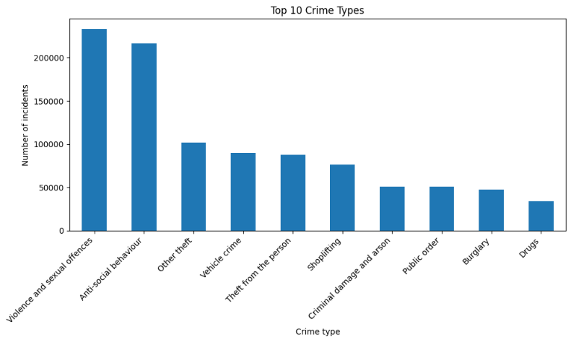
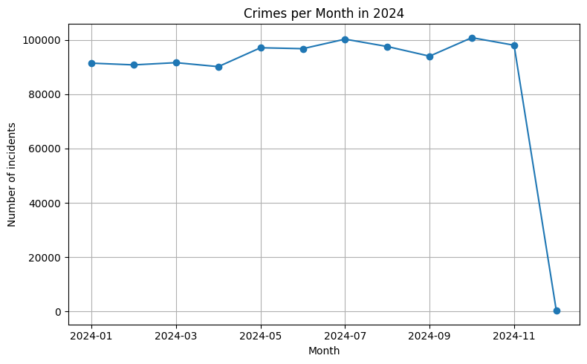
Figure 2. Monthly Crime Trends in 2024.

Figure 3. Spatial Distribution of Crime Location
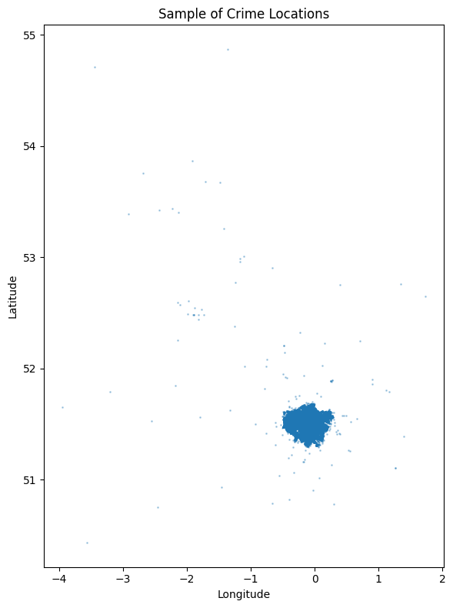
Figure 4. Top 10 LOSAs by Crime Count.
